Configure maven and maven project:🡪

1. Install Java into Computer
2. Create Environment variable for JAVA-HOME

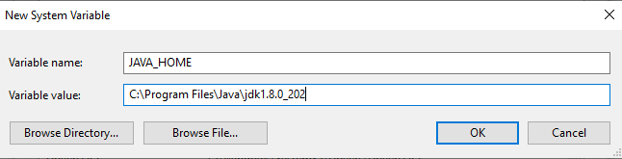

1. Set java bin location at path variable

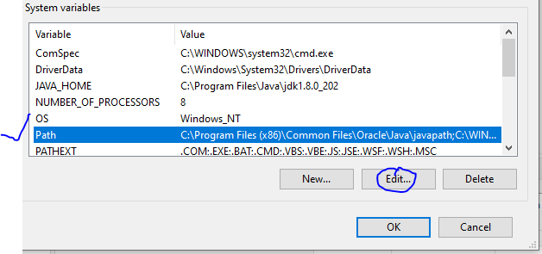

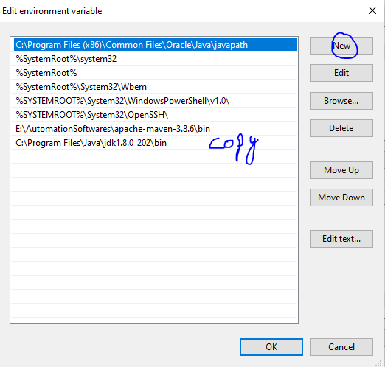

Click on New button and copy path up to bin location.

Download Maven:🡪

<https://maven.apache.org/download.cgi>

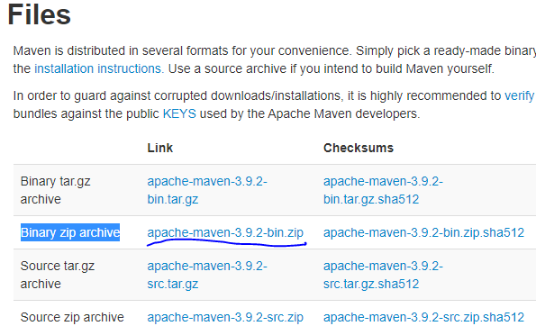

* Under files click binary zip format file
* Create folder and name it as maven
* Unzip maven zip file to maven folder
* After unzip create environment variable for maven home

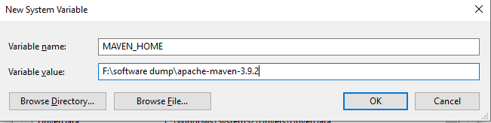

Add bin location at path variable



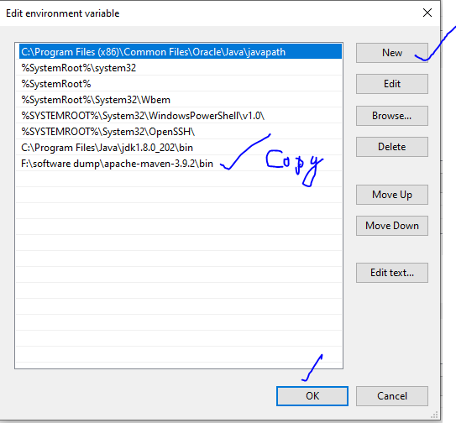

Check maven installation using command line

Open Command line

Enter :🡪 mvn –version Press Enter

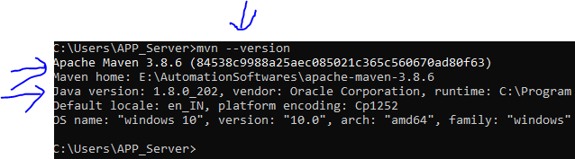

Create maven Project at eclipse:🡪

* At eclipse open “ file menu” and choose “new “option and select “project”

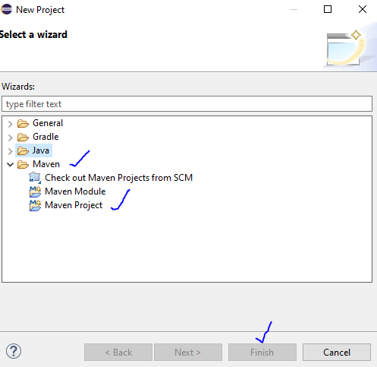

* Click on “maven folder” select “maven project’ and click on next

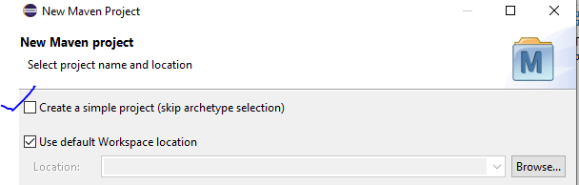

* Select check box “Create simple project” and click on next button

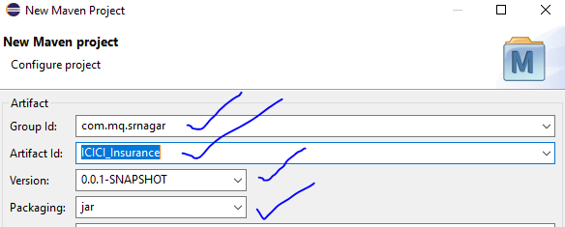

GroupID:🡪 it is a package name [Enter any name]

Artiface ID:🡪 It is a project name [Enter any name]

Version:🡪 Project version [You can edit version]

Packaging:🡪 Keep the jar file

Click on Finish button

With is action your project will be created , You case see project details same as bellow

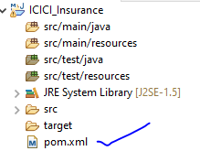

* Double Click on POM.xml fil

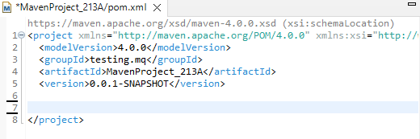

Search for maven dependencies at “maven repository”

https://mvnrepository.com/

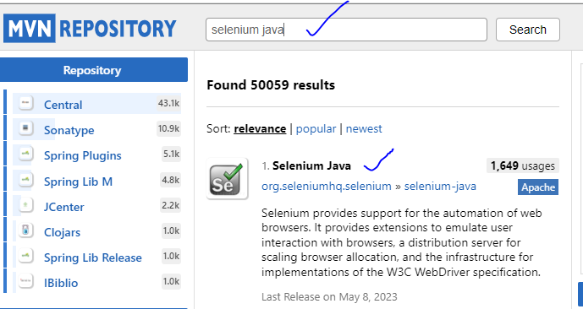

* Search for “Selenium java”
* Click on Selenium java from “org.seleniumhq.selenium”
* Click on selenium version

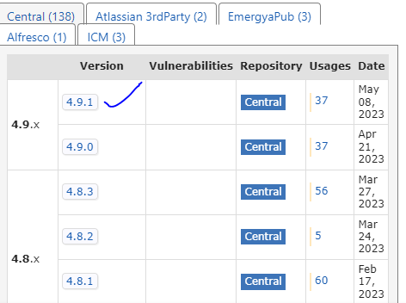

After open selenium version page just tap on maven dependency

It will select entire maven dependency with single tap

Copy selection and add dependency at POM Xml file

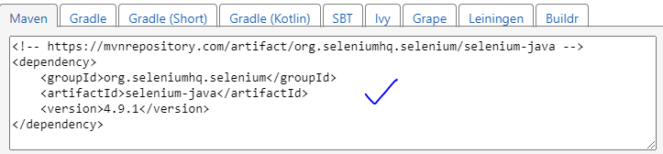

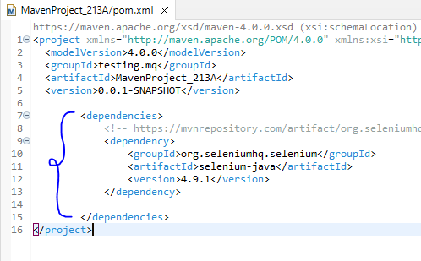

* Save POM xml file

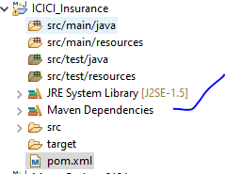

* After save you can see maven dependencies under project